What God Hears Every Day
(by Kent Heaton)
“Behold, the Lord’s hand is not shortened, that it cannot save, or His ear dull, that it cannot hear; but your iniquities have made a separation between you and your God, and your sins have hidden His face from you so that He does not hear” (Isaiah 59:1-2). Trying to understand the nature of God is an effort of gargantuan measure and yet at the end of the day the hem of the garment has yet to be touched. Where does one begin to unravel the mystery of how completely overwhelming the presence of the Almighty is? Isaiah reminds us that we are mere dust in the presence of the Lord (40:15). What then can we imagine our Creator endures each day as He hears all the activities of man on the face of the earth?
The omniscience of God comes to His ears and with His eyes He declares His omnipresence. Every day people are murdered, raped, abused, starved, tortured, in peril, dying from disease or natural causes. Statistics are impossible to know the true number of human beings that are slaughtered on the altar of man’s inhumanity to man. And God hears every cry, every whimper of a hungry child, every moan of agony and every scream of fright that takes place every minute of every day on the face of the earth. The Lord hears every act of sin (Isaiah 37:17). One of the greatest acts of God’s mercy is that He does not destroy the world today for all the evil He hears.
Peter reminds us the Lord hears many other things. “For the eyes of the Lord are on the righteous, and his ears are open to their prayer” (1 Peter 3:12). In the midst of such evil as it prevails the character of man the bright hope of righteousness shines forth as the ear of God hears the glorious chorus of the saints who worship and praise Him. Nehemiah begged the Lord to let His ear be attentive to Nehemiah’s prayers (Nehemiah 1:11). The Lord heard the words of a man who delighted to fear the name of Jehovah and granted the request of Nehemiah. Paul and Silas were in a Roman prison “praying and singing hymns to God” and He basked in their melody of praise (Acts 16:25). When the eunuch of Ethiopia made the good confession, “I believe that Jesus Christ is the Son of God” (Acts 8:37) the angels rejoiced with the Father to hear of another child born into the Kingdom.
Every day people do kind deeds, express graceful words, sing songs of joy to the Lord, feed the hungry and clothe the naked. God hears all these acts of man’s greatest humanity to man in loving their neighbor as themselves. What God hears every day will be determined by what we do every day. He ponders our lives in every detail and knows all that we say and do and think (Proverbs 5:21). The omnipotence of God will bring every word to His throne in the judgment day as He has heard every word we have said “including every secret thing, whether it is good or whether it is evil” (Ecclesiastes 12:14).
The ear of the Lord is not dull that it cannot hear: it hears everything! How many things He hears that saddens His heart yet how many of the righteous lift His spirits with their prayers, petitions, expressions of love, and praise to the one that gave His only begotten Son for man to hear the ring of redemption. What a great God we serve. How wonderful to be part of a covenant that enjoys the richness of the ear of God. May our hearts be filled with the sound of the word of God as He speaks to us by His grace.

The Pruning Beetle
(by Mary Batten)
One of the most incredibly timed operations in nature is accomplished by a beetle known as the Mimosa Girdler beetle. The female beetle is attracted to the unique odor of the mimosa tree where she will spend her entire life. When she gets ready to lay her eggs she climbs out to the end of a small limb, cuts a slit in the bark and lays her eggs under the slit, but the girdler beetle does one last thing to insure the survival of its offspring. After laying its eggs, the female crawls back to the middle of the same branch and gnaws a ring or girdle all the way around. The deep cut stops circulation in the limb and the limb begins to die. The incredible thing about all this is that the length of time it takes the limb to die is exactly the same as the time required for the beetle's eggs to hatch. When this time is elapsed the limb gives way and crashes to the ground scattering the beetle's baby beetles.
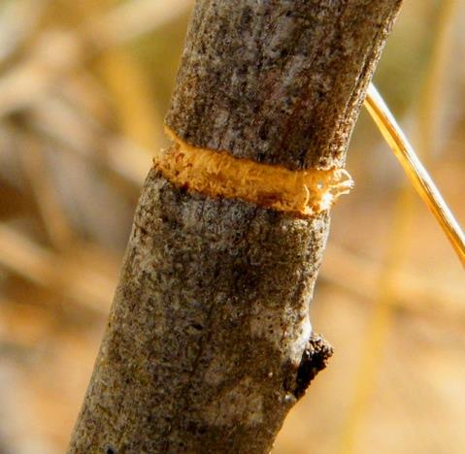
The nature of the mimosa tree helps make this such a beautifully functional system because it is brittle enough to break in a consistent way. Interestingly enough, the arrangement is also an advantage to the tree. By pruning the tree, the beetle stimulates new growth and allows the tree to survive about twice as long as it would without pruning. This symbiotic relationship is another beautiful demonstration of the wisdom built into the creation. Design abounds in our world, ruling out chance as a creative process and demonstrating the wisdom and power of God.

