The Culture War on Christians
(by Ken Weliever)
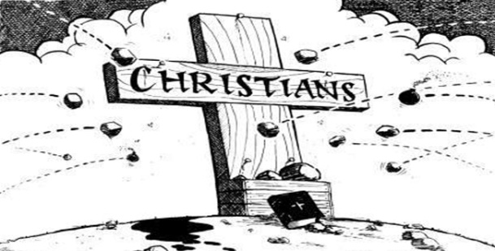
Culture War. It’s a term used to describe two conflicting sets of values. The struggle between conservative, traditional values and more liberal, progressive values. It’s a clash of beliefs about what is truth. Especially in areas of religion, morals and Biblical teaching. While conflict between Christians and culture is nothing new, it’s disconcerting to witness such a dramatic change in America’s values over the past 40-50 years.
It’s Not the 50′s Anymore!
William Buckley, the conservative columnist, illustrates it this way.
Ingrid Bergman was invited by Ed Sullivan to appear on his program around 1958 when she was living with an Italian film producer. She had left her husband and had a child. Before she actually went on the show, there was such a public clamor that he couldn’t have her on. Can you imagine?
Today, movies, sitcoms, and talk shows present every kind of bizarre lifestyle imaginable. And some you can’t! In fact, they not only show it, but revel in it, glorify it and promote it. As a child of the 1950’s, I find it sad that there is a loss of innocence among today’s children. However, this trend which has been rapidly increasing for the past 15-20 years is now taking a new turn.
Anti Christian Bias
Christian conservatives are now facing an increased, open onslaught of criticism from the liberal media, politicians, and educators unlike anything in our life time.
Daniel Lapin, a Jewish Rabbi, posted an internet article entitled “A Rabbi’s warning to U.S. Christians.” In it he lists just a few of the anti-Christian books published from mainstream publishers.
“The End of Faith: Religion, Terror, and the Future of Reason”
“Piety & Politics: The Right-wing Assault on Religious Freedom”
“Atheist Universe: The Thinking Person’s Answer to Christian Fundamentalism”
“Religion Gone Bad: The Hidden Dangers of the Christian Right”
Lapin correctly observes that there would be an incredible outcry if these books were written regarding Jews. The authors and publishers would be accused of Anti-Semitism, and attacked by every liberal news agency in the country.
Christians are the New Intolerant
Dr. Chris Hedges is a journalist and author of “American Fascists: The Christian Right and War on America.” When he was invited to speak at Princeton Theological Seminary, he began his lecture from the opening of his new book by quoting Karl Popper: “We should therefore claim, in the name of tolerance, the right not to tolerate the intolerant. We should claim that any movement preaching intolerance places itself outside the law, and we should consider incitement to intolerance and persecution as criminal, in the same way as we should consider incitement to murder, or to kidnapping, or to the revival of the slave trade, as criminal.”
It is reported that he continued to equate fundamentalist evangelicalism with Nazism, and compared the religious right to living in Nazi, Germany in the 1930’s.
Liberals are fighting mad. They are tired of Christians condemning sin and alternative lifestyles like homosexuality. They see us as narrow-minded and bigoted. Our secular culture today would like nothing better than to eradicate every vestige of the religion of Jesus Christ and the moral code it espouses from American culture and the world. Now, at least, they are admitting, that it’s alright for them to be intolerant of us! Of course, we must be tolerant of them and their beliefs!
What’s a Christian to Do?
1. Realize what is, has already been (1 Corinthians 10:12-13). Paul Harvey once said, “In times like these it is good to remember that there have always been times like these.” Indeed there is nothing new under the sun. New Testament Christianity faced intolerance, misrepresentation by their enemies and even severe persecution. They faced it and remained faithful. So can we.
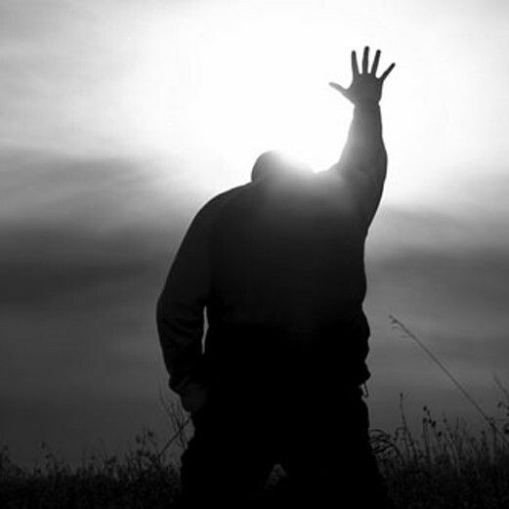
2. Put our faith in God (Mark 11:22) The answer to our problems is not found in government, political parties or social programs. God is not oblivious to our challenges. He will vindicate the righteous in His time.
3. Pray (1 Timothy 2:1-2) We need to pray for our leaders. Our country. The lost. For ourselves. The all-powerful God hears our prayers.
4. Be salt and be light (Matthew 5:13-18). Christians have many opportunities to make a difference in the world. Be honest in your business. Be faithful to your spouse. Live righteous and godly among your neighbors. Practice the golden rule.
5. Share Your faith (1 Peter 3:15). Don’t be afraid to speak up. Let others know where you stand and what you believe. Do it kindly. Do it humbly. But let it be known that not everyone agrees with today’s sinful culture.
Yes, these are perilous times. But “if God be for us, who can be against us”?

