The Death of the Testator
(by Kent Heaton)
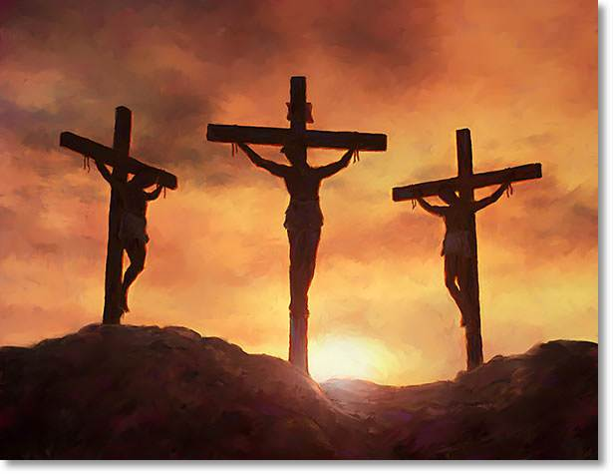
A will is a legal document that sets forth the manner an individual entrusts his inheritance to be carried out following their death. Contained within the wording of the will is language that clearly states the means of inheritance, promises given when the testament is carried out and all declarations pertaining to the wishes of the one executing the will. The single clause that makes a will binding or not is whether the person is still living. Before death a will can be changed innumerable times but after death cannot be changed. In death, the testimony of the will is enforced.
The writer of Hebrews explains what happened when Jesus Christ died on a cross outside of Jerusalem. “And for this reason He is the Mediator of the new covenant, by means of death, for the redemption of the transgressions under the first covenant, that those who are called may receive the promise of the eternal inheritance. For where there is a testament, there must also of necessity be the death of the testator. For a testament is in force after men are dead, since it has no power at all while the testator lives” (Hebrews 9:15-17).
Hebrew (Jewish) Christians were struggling with their faith and had suffered great persecution (Hebrews 10:32-34). The writer pleads with them not to “cast away your confidence which has great reward” (Hebrews 10:35). They had come so far and enjoyed the blessings of salvation in Christ and needed endurance to receive the promise (Hebrews 10:36-39). What they had to focus on was the new covenant of blessings enjoyed in Christ. They had a better hope (7:19), a better covenant (7:22; 8:6), better sacrifices (9:23), better possession (10:34), better country (11:16) and better provisions from God (11:40). The Law of Moses could promise none of these and only in the salvation of Jesus Christ would redemption be found (9:15).
The death of Christ (the testator) affirmed His will for all mankind. Jesus died to take away the curse of the law and the sting of death (1 Corinthians 15:54-57). Man can no longer be saved by keeping the law as Noah or Abraham followed. Salvation will not be found in the Law of Moses (including the Ten Commandments) because “it is not possible that the blood of bulls and goats could take away sins” (Hebrews 10:4). The death of the testator Christ established His will and nullified all covenants before the cross.
Salvation is in the blood of Christ (Ephesians 2:13) and the will of the Father is established in the death of Jesus when the new testament of grace was enacted. Those who live in accordance with the new testament of God’s will enjoy the blessing of inheritance (Romans 8:15-16). Affirmed by His death Jesus created the avenue of redemption under the law of grace. The Jew can no longer be saved by Moses’ law nor modern day Sabbath keepers. Seeking justification by the old law will find one outside the legal parameters of the binding nature of the last will and testament of Jesus Christ.
In Philippi the jailor asked, “Sirs what must I do to be saved?” Paul and Silas “spoke the word of the Lord” (Acts 16:30-34) to them in accordance with the will of the testator Jesus Christ. As proclaimers of His WILL we must do the same. Preaching the word is preaching the WILL of Christ. If we do not preach the WILL of God then we are teaching a false document of hope.

He Just Called To Talk
(by Mark Moseley)
“Devote yourselves to prayer, keeping alert in it with an attitude of thanksgiving” (Colossians 4:2)
I received a phone call from my youngest son. He was on his way to Best Buy with Carrie, the love of his life. He didn't have a question. He didn't have a complaint. He didn't ask for anything or confess anything. He didn't call to make a promise or even to seek my advice. There was no crisis or compelling reason for this phone call. He just called to pass the time for a few minutes. He called to let me know what was going on in his life. He called to keep in touch. He called "just to talk." And I was delighted.
Today, I would make the observation that prayer is a multi-faceted issue. I could write devotions for an entire year on prayer and not exhaust the topic. But the complexity of some aspects of prayer should not diminish the glory of its simplicity. There are many reasons why we should pray and, correspondingly, many different kinds of prayers to be offered – prayers of petition, prayers of thanksgiving, prayers of confession, prayers of intercession, prayers for help, and prayers of praise to name a few. But I was reminded while talking to Nathan how much I just enjoy hearing from him. I was reminded that some of the best calls I've ever received from any of my children involved nothing more than hearing about their day.
Maybe it's because I'm glad to know they want to talk to me. Maybe it's because it confirms that they know I take interest and delight in the most ordinary events of their lives. Maybe it's because these little strands of contact form the threads that ultimately weave together to form the strong bonds between us.
If you ever have trouble praying because you cannot think of all the things you need and want to say, don't fret. Try this – tell your Father about your day. He'll be glad to hear from you. Today's Prayer – "Father, I just wanted to bow my head for a moment and bask in Your presence. I wanted to let You know that I'm enjoying this beautiful day that You have created – even if it is mostly through my office window. I needed to be reminded that You are always near. And I wanted to tell You that I haven't forgotten You this day and that I long to see Your face."

