The Eternal Cliff
(by Kent Heaton)
Do you remember the end of the year drama in Washington that concluded with President Obama signing into law a deal averting the “fiscal cliff” which threatened the financial and political economy of America? Fear loomed in the early hours of the New Year if the House and Senate failed to find a solution to the gridlock of political wrangling and debate over tax increases and spending cuts. With the normal fashion of the rabid media blitz driving the fears of a looming disaster the country sighs a moment of relief before the continuing crisis of prosperity engulfs every home. America has pulled itself back from an uncertain future as described in falling off a cliff. But there is still another cliff that emerges on the horizon for all men – an eternal cliff.
There is a precipice that is more to be feared than a fiscal cliff, political cliff or literally falling off a mountain cliff. Death is the agent that carries one into a world where there is no return. When life is over and one falls over the cliff of time into the chasm of eternity there are greater consequences than whether taxes go up or down or money is cut from large budgets or small budgets. The certainty of this cliff is found in Hebrews 9:26, “And as it is appointed for men to die once, but after this the judgment.” The “after this” is the eternal cliff. The rich man and Lazarus fell over
this eternal cliff in Luke 16:19-31. “So it was that the beggar died, and was carried by the angels to Abraham's bosom. The rich man also died and was buried” (Luke 16:22). This cliff is no respecter of person. You can wear expensive clothes every day and make incredible amounts of money living at the high end of prosperity and die just like the fellow at the front gate who is a beggar starving to death ill with the misery of humanity. The President can sign a bill into law averting the fiscal cliff but no man will change the reality of an eternal cliff that awaits all men.
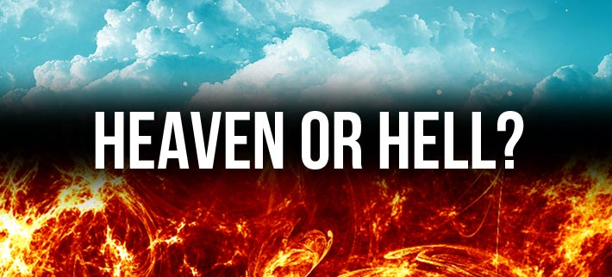
If men were more concerned about life beyond the grave than living beyond the dollar bill what a difference the world would be. Sadly, the eyes of man are closed by the deceiver of this world. Paul writes, “Whose minds the god of this age has blinded, who do not believe, lest the light of the gospel of the glory of Christ, who is the image of God, should shine on them” (2 Corinthians 4:4). Satan does not want man to see the pit he is taking most men (Matthew 7:13-14). There would be greater fear of falling off the eternal pit if we could fully grasp the reality of “everlasting punishment” (Matthew 25:46).
Jesus “signed a bill” nearly two thousand years ago that extended to all men His Father’s grace to avert the eternal cliff of doom. With the blood of God’s Son humanity was offered the chance to pull back from the fear of death and punishment of a Just God. “In Him we have redemption through His blood, the forgiveness of sins, according to the riches of His grace” (Ephesians 1:7). What Jesus did on the cross is not a temporary measure but an eternal promise that guarantees inheritance to all who will accept the terms of His law (Ephesians 1:14; Matthew 7:21-23).
Peter reminds us the world will come to an end (2 Peter 3). When that day happens (and it will) no one will worry about the fiscal cliff. Everyone will know there is an eternal cliff and the few (Matthew 20:16) will have joy (2 Thessalonians 1:10) but the vast majority of men who did not believe in the eternal cliff will know the fear of the Lord.

Would You Go Back?
(by Gary Henry)
“Remember Lot’s wife” (Luke 17:32). DO YOU EVER LOOK BACK LONGINGLY AT ANYTHING IN THE PAST? Do you ever wish you had back anything that you gave up for the Lord? If you could go back in time, would you go back?
REGRET. Leaving Sodom was the right thing to do. It was a sacrifice made for the Lord. We don’t know much about what Lot’s thoughts were, but the fact that his wife “looked back” (Genesis 19:26) seems to suggest some regret on her part, regret that the Lord’s requirement had cost her something she didn’t want to give up. Regret in itself is not wrong, but if regret means that we “begrudge” not having what we once had, then that is not good.
RESENTMENT. Worse than wrongful regret would be RESENTMENT that something we once had in the past has been “taken away” from us. When we think about the past, we may almost be filled with a bitterness or an anger that what was “ours” was unfairly removed from our possession. We are creatures who are prone to possessiveness and the protection of our “rights,” and our memories often tempt us to believe that we have been “deprived.”
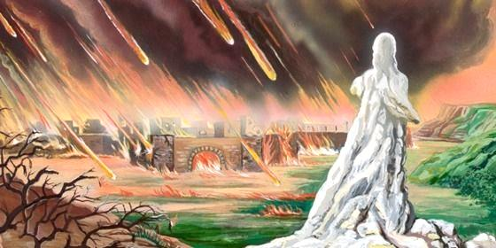
RECONSIDERATION. Worst of all, of course, we sometimes even RECONSIDER whether we made the right choice when we left behind something that was hard to give up. The tempting thought may occur to us to try to go back to our previous situation and resume the life that we had back then. If it was Sodom that we left, we certainly ought not to go back, but even if it was something good that we gave up for the Lord, going back is rarely, if ever, the answer.
Memory is a two-edged sword, is it not? With it we may remember (helpfully) things that can energize us, but with it we may also remember (hurtfully) things that can hold us back. For fallen creatures such as we, there is no such thing as no regrets, but we need to be very careful. As someone has said, “The past is valuable as a guidepost, but dangerous if used as a hitching post.” When we remember the past, as we certainly will, our effort must be to remember it with such an attitude that we are HELPED in the here and now. God intends for our lives to go FORWARD — and when we’re tempted to go BACKWARD, we need to remember Lot’s wife.

