“I Refuse To Live By Faith!” & Other Foolish Comments
(by Martin Pickup)
Everybody lives a life of faith. And I mean everybody ... even atheists and agnostics. I am not saying that everybody puts their faith in Jesus Christ, of course. But every human being lives his life believing in things for which he does not have firsthand knowledge or absolute proof.
Nonreligious people often deny that they act on the basis of faith. They may even take jabs at those of us who are religious, scoffing at us for what they see as a foolish need to believe in something just to make it through life each day. Since the New Testament emphasizes salvation through faith in Jesus Christ, Christians are special fodder for this kind of derision. The implication is that anyone who believes in a supernatural realm or a divine Creator is either unintelligent or just plain childish. "But not me!”—says the atheist. "My intellect won't allow me to live life the way you Christians do, believing in someone or something you can't see or perceive with your own senses. I live a life of reason, and I accept as true only what I can absolutely prove." The irony here is that the person who mocks the idea of living by faith is only displaying his own ignorance. He is deluded about himself and about the limitations of human knowledge. His boast
about living life without having to accept anything by faith is a figment of his imagination. The truth is that atheists and agnostics live by faith every bit as much as Christians do. Let me show you what I mean.
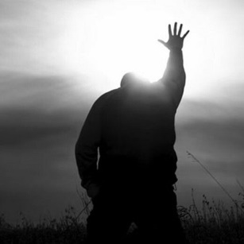
The Necessity of Faith – Human beings are finite creatures, and as such it is impossible for any of us to have direct, personal knowledge of everything. For this reason we constantly accept things by faith. We accept the word of our friends and neighbors when they recommend a good movie or nice restaurant. We accept the word of our instructors in school because we have confidence in their scholarship. We believe what we read in the newspapers and what we hear on the nightly news broadcasts because we trust the veracity and investigative ability of the reporters. All of the above are occasions where we rely upon the evidence of facts for which we do not have first-hand knowledge since we did not observe them ourselves. We continue to have faith in the testimony of people we've come to trust unless and until they let us down. If a television news show gets the facts wrong on one too many occasions, or if they begin to manifest an unfair bias, we become upset and bark about how unreliable they are. Yet even then we don't stop walking by faith. We just change the TV channel and put our faith in another news station.
Acts of faith are such a regular part of our everyday lives that we tend not to be conscious of them. Nor is it only in minor matters that we resort to faith. We walk by faith even in the things of life that are the most important to us. We entrust our children to daycare workers and babysitters. We take the word of our mechanic who says that our vehicle is repaired and now safe to drive on the highway. We trust our
doctor when he diagnoses our illness, prescribes a medication, or performs surgery. The list goes on and on.
Once a person begins to reflect on all of this, it becomes glaringly obvious just how many aspects of life there are that require us to put our faith in other people and to rely upon what they tell us. Living by faith simply cannot be avoided. Do you realize that your knowledge of history is totally dependent upon the accounts of alleged eyewitnesses and records of events of the past? Perhaps you've never thought about it before but, short of getting a DNA test, it is only the faith that you have in the integrity and moral fidelity of your mother that allows you to "know" that the man you call Dad is really your father!
Now I am not suggesting that we don't have good reasons for believing what we believe and for trusting those whom we trust. To say that one takes something on faith does not mean that there is no rational reason for doing so. Faith, almost always, is based upon some degree of evidence. But again, the evidence of faith is always of an indirect nature rather than the result of one's own personal observation, and for that reason it can never produce in us a confidence that rises to a level of absolute knowledge. Still, if the people upon whom we rely are credible enough, or if the evidence is convincing enough, we choose to accept a thing by faith and live accordingly.
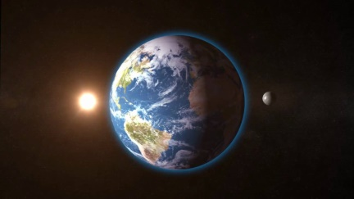
The Atheist – The issue between an atheist and a Christian, therefore, is not whether a person should live by faith or not live by faith. We must live by faith whether we like it or not. The issue is simply this: what are we going to believe, and why? It seems to me that the evidence for an intelligent Creator of this universe is all around us. It is far more credible to me to believe that the intricate workings of nature, and of the cosmos as a whole, are the result of design rather than blind chance. I choose therefore to believe in God. The atheist chooses not to do so. His reasoning escapes me, for he would rather have faith in the power of chance evolutionary processes than intelligent design. So be it. But the atheist is just as much a person of faith as I am. Now if he will admit this inarguable fact about himself, then he and I can begin to have a good discussion about our respective walks of faith. I'll explain to him why I have chosen the path of theism, and he can explain to me why he has opted for the path of atheism. I think he may eventually discover the reasonableness of the path I've chosen, and perhaps come to see that it really is a pretty good road.
“Go therefore and make disciples of all the nations, baptizing them in the name of the Father and of the Son and of the Holy Spirit…" (Matthew 28:18-20).

