**Drawing Strength from Courage of Others**

(by Bill Hall)

How thankful we should be for wonderful examples of courage that spur us on to greater strength in the Lord's service. Paul was just such an example: ***"And many of the brethren in the Lord, waxing confident by my bonds, are much more bold to speak the word without fear"*** (**Phil. 1:14**). These brethren, formerly timid and reticent, were drawing strength from the courage of Paul.

Other examples abound. Stephen's plea, ***“Lord, lay not this sin to their charge,"*** surely had for its source of strength the forgiving spirit of the Lord (**Acts 7:60**). The Thessalonian church found a source of strength in the example of the churches in Judea (**1 Thess. 2:14**).

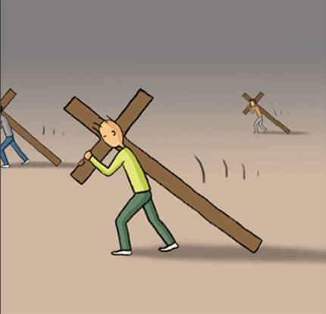The Philippian church, a model of courage and conviction, could no doubt trace much of its strength back to the wonderful example of patience and equanimity demonstrated by Paul and Silas while in their midst. The Hebrew Christians were admonished to ***"remember them that had the rule over you, men that spake unto you the word of God; and considering the issue of their life, imitate their faith"*** (**Heb. 13:7**).

Christians of this generation are similarly drawing strength from the courage of others. Young men who refuse to miss services of the church to play on a ball team; young women who refuse to be seen in public in scanty attire; businessmen who would lose their jobs rather than compromise their convictions; women who continue to adorn themselves in *"meek and quiet spirits"* whatever the sophisticated world thinks or says of them; sick people who bear their afflictions with patience and faith; elderly people who continue to attend worship when they are hardly able to go anywhere else; dying people who demonstrate how Christians ought to die; all are sources of strength and courage for others as they face similar circumstances. These all share a common spirit with the great characters of the Bible: they see in their temptations, trials, afflictions, and persecutions a special opportunity to be like Christ, to demonstrate their fidelity to Him, and to provide a source of strength for those who might be weak and wavering around them. They seize the opportunity and stand, and all of us are stronger because of them. Of these courageous people this world truly is not worthy.

Are we, however, to be always on the receiving end of the strength of others? As we draw strength from the courage of others, we must in turn become sources of strength and courage. Others look to us. Each of us has a *"charge to keep," "God to glorify,"* and *“a present age to serve."*

**Four Ways For Furtherance**

This way that way(by Dee Bowman)

1.    **Know which direction you’re going.** Have you a plan? I mean a spiritual plan? It’s hard to get where you’re going when you don’t know where you’re going.

2.    **Hold on tight.** There are always potholes. And detours. And junk in the road. And turns hard to negotiate. Hold on. Don’t let go.

3.    **Keep your speed up.** It’s like riding a bicycle. If you don’t keep up your speed, you’ll fall over.

4.    **Remember where the road leads.** A goal is necessary. When the goal is heaven, there’s no way you can quit because you know where the road ends.

**Salt of the Earth**

(by Bubba Garner)

Jesus referred to this account with a simple statement, ***“Remember Lot’s wife”*** (**Luke 17:32**). Notice that He didn’t have to say, *“Remember Lot’s wife, the one who became a pillar of salt.”* They knew her story. They may not have known her name, but they knew her lot in life. Still, they continued to turn back from God.

In reflecting on this story, Jesus wanted them to remember that: God does not ask the impossible. There was nothing too difficult about what He commanded Lot’s family. ***“Escape for your life! Do not look behind you”*** (**vs. 17**). That was simple and straightforward, without room for misunderstanding.

He didn’t require them to do something they were incapable of doing. His commandments do not create burdens, they lift them. God does not give partial credit. Lot’s wife almost got it right. She escaped for her life, she left the city, but she looked back and became a pillar of salt.

With God, there is no such thing as partial obedience; to obey in part is to disobey. You can’t pick and choose parts of His law and discard the rest. Do it all or you have done nothing at all.

AP1127God does assess punishment on those who disobey. She became a pillar of salt. This woman became a testimony to all generations of what happens when you disobey the commandments of the Lord. *“It is our business to see that we do right. God will see that we come out right”* (Donald Barnhouse). In due season.