Are Babies Born In Sin?
(by Kipp Cambell)
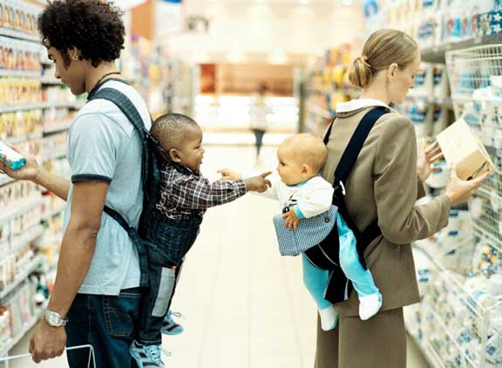
One prevalent religious doctrine today is the idea that babies are born in sin. It is the concept known as “Original Sin” or “Adamic Sin.” The thought for this teaching goes back to Adam and Eve and the sin that was committed in the Garden of Eden. Those who hold this doctrine believe the guilt of the sin Adam and Eve committed is passed on from generation to generation. Thus, when the baby is born, it needs to be “baptized.” While this doctrine may seem reasonable on the surface, we have to make sure it stands up to Bible scrutiny. Does the Bible teach babies are in need of being baptized for fear of spending eternity in hell? I submit to you the answer is no. Here are four reasons why I believe infant baptism is not a biblical doctrine.
No Example in the Scriptures of Babies Being Baptized. The Scriptures offer no example of children (babies) being baptized for the remission of their sins. A passage that is used in support of the Original Sin idea is found in Acts 16:15. Luke records for us, “And when she and her household had been baptized, she urged us, saying, ‘If you have judged me to be faithful to the Lord, come into my house and stay.’ And she prevailed upon us.” The conclusion drawn from this passage is that because Lydia’s household was baptized it automatically includes children (babies). However, there is a problem with this reasoning: How do we know Lydia had any young children? How do we know she had any children? How do we know she was even married? These are questions that can’t be answered from the text. The use of the word “household” causes some people to assume there were children living in the same house as Lydia. Some people, when thinking about this word, apply today’s meaning. For example, when we think of the word “household” today we think of two parents and children. The Greek word for household (oikos), however, simply meant… the inhabitants of the house. It could describe a home with two parents and children or it could describe the owner of the house and servants. During ancient times everyone who lived under the same roof were counted as members of that household. We cannot make assumptions on things we simply don’t know.
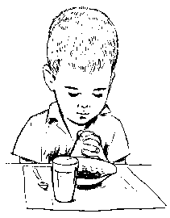
Infant Baptism is Not a New Testament Teaching. The overwhelming evidence shows infant baptism to be a man-made doctrine. The main reason I say that is because it is not mentioned in the Scriptures. Another reason this doctrine is man-made is because as a practice it was not advocated until 150 AD. This is interesting because the doctrine of total hereditary depravity (Original Sin) was not taught in full force until 400 AD. Also, it wasn’t until the same year (400 AD) that infant baptism was taught as a necessity. The necessity of this practice came much later than it’s beginning. The obvious conclusion we are left to make is that this is a doctrine originated with man and not God. The Bible warns us against attributing things to God that He never said or implied, Revelation 22:18.
Babies Are Not Capable of Being Believers. A major criterion for obeying the gospel in baptism is belief, John 3:16; 6:47. Jesus said in Mark 16:16, “He who has believed and has been baptized shall be saved; but he who has disbelieved shall be condemned.” We see here that belief and baptism are considered as equals. The result of having these two components together is salvation. You can’t have one without the other. We also might note that both of these are actions one must willingly participate in. Neither can be forced upon a person. Let me illustrate it this way: How can a baby (or young child) willingly commit to something they do not understand? Have you ever tried explaining the salvation process to a newborn? Impossible! Young children simply cannot “put it all together” and therefore are not in need of being forgiven of their sins.
The Sins of the Father Are Not Passed on to the Children. While our children may suffer the consequences of our actions (and vice versa) they are not responsible for what we as their parents do. In Ezekiel 18:19-20 God said, “Yet you say, ‘Why should the son not bear the punishment for the father’s iniquity?’ When the son has practiced righteousness, and has observed all My statutes and done them, he shall surely live. The person who sins will die. The son will not bear the punishment for the father’s iniquity; the righteousness of the righteous will be upon himself, and the wickedness of the wicked will be upon himself.” God understood it is not just for people to be punished for something they did not do. This principle is continued in the New Testament, “For we must all appear before the judgment seat of Christ, that each one may be recompensed for his deeds in the body, according to what he has done, whether good or bad,” 2 Corinthians 5:10. In both of these examples the thought is the same; we will all be judged by what we do, not by what others do. I am not responsible for the sins of my father, just as my sons are not responsible for my sins. Children cannot be held responsible for actions they haven’t engaged in.
Children Have Nothing to Fear. Young children are in no need of baptism because they have done nothing for which they need to be forgiven. Until they reach the understanding of God’s law, they cannot be held accountable for their actions, Isaiah 7:14-15. Thus, when a baby is born there is no need for it to be “baptized.” Those who are in need of baptism are those of sound age who recognize right from wrong according to God’s word. When that recognition is made it is incumbent upon us to act. We must not wait around for a better time because there is no better time than the present to make our lives right with God. Take God up on His gracious offer of salvation and let Him change your life for the better.

